
  TEACHER COPY
  Not for students

MATHEMATICS
Year 9 5.2
Yearly Exam
2026
Marking Guide

Notes for markers  1. Full marks for a correct answer unless the question asks for working.  2. Follow-through: a later part that uses an earlier wrong answer correctly earns its marks.  3. Units: do not deduct for missing units; note it for feedback.  4. Rounding: deduct only where the criteria say so.  5. Green = Foundation, Blue = Standard (Test yourself levels). |  | Sections and Marks
  Section 1 - Data  11 green · 6 blue | /17
  Section 2 - Surface area and volume  12 green · 10 blue | /22
  Section 3 - Mixed Topics  26 green · 7 blue | /33
  Total marks | /72

Section | Marks | Share | ■ Green | ● Blue | Questions
Section 1 - Data | 17 | 23.6% | 11 | 6 | 4 MC · 1 SA · 2 WP
Section 2 - Surface area and volume | 22 | 30.6% | 12 | 10 | 4 MC · 3 SA · 2 WP
Section 3 - Mixed Topics | 33 | 45.8% | 26 | 7 | 5 MC · 7 SA · 3 WP
Total | 72 | 100% | 49 (68.1%) | 23 (31.9%)

Section 1 answer summary – Data
Q | Answer | Marks | Level | Topic and source
1 | D (The time taken to swim 50 m) | 1 | ■ Green | Classifying data  TY9 Q9 (9.05, green)
2 | B (Negatively skewed, clustered at 8 and 9) | 1 | ■ Green | Shape of a distribution (dot plot)  TY9 Q6a (9.03, green)
3 | A (2) | 1 | ■ Green | Mode from a histogram  TY9 Q4b (9.02, green)
4 | C (The mean) | 1 | ■ Green | Effect of an outlier  TY9 Q2c and Q3c-d (9.01, 9.02, green)
5a | 25 minutes | 2 | ■ Green | Mean and median from a stem-and-leaf plot  TY9 Q3b (9.02, green)
5b | 24 minutes | 1 | ■ Green | Mean and median from a stem-and-leaf plot  TY9 Q3b (9.02, green)
6a | 16 students | 1 | ■ Green | Reading a column graph  TY9 Q4 (9.02, green)
6b | 60 students | 1 | ■ Green | Reading a column graph  TY9 Q4 (9.02, green)
6c | 40% | 2 | ■ Green | Reading a column graph  TY9 Q4 (9.02, green)
7a | Kestrels: 39; Tigers: 42.5 | 2 | ● Blue | Comparing two data sets (back-to-back stem-and-leaf plot)  TY9 Q7 (9.04, blue)
7b | The Tigers: their median (42.5) is higher than the Kestrels’ (39). | 1 | ● Blue | Comparing two data sets (back-to-back stem-and-leaf plot)  TY9 Q7 (9.04, blue)
7c | The Kestrels: their range is 15 goals (46 − 31), much smaller than the Tigers’ 35 goals (57 − 22). | 3 | ● Blue | Comparing two data sets (back-to-back stem-and-leaf plot)  TY9 Q7 (9.04, blue)
 | Total | 17 | 11 green · 6 blue

Section 2 answer summary – Surface area and volume
Q | Answer | Marks | Level | Topic and source
1 | C (4600 L) | 1 | ■ Green | Metric units: capacity (kL to L)  TY10 Q1i (10.01, green)
2 | A (±25 mL) | 1 | ■ Green | Precision and absolute error  TY10 Q2 (10.02, green)
3 | D (72 cm²) | 1 | ■ Green | Area of a parallelogram  TY10 Q6a (10.05, green)
4 | B (176 cm²) | 1 | ■ Green | Area of a kite  TY10 Q6b (10.05, green)
5a | 36 cm | 1 | ■ Green | Perimeter and area of a triangle  TY10 Q4 and Q5 (10.04, green)

Section 2 answer summary – Surface area and volume (continued)
Q | Answer | Marks | Level | Topic and source
5b | 54 cm² | 1 | ■ Green | Perimeter and area of a triangle  TY10 Q4 and Q5 (10.04, green)
6a | 40.8 cm | 1 | ● Blue | Circumference and area of a circle  TY10 Q7 (10.06, blue)
6b | 132.7 cm² | 1 | ● Blue | Circumference and area of a circle  TY10 Q7 (10.06, blue)
7a | 1696.5 cm³ | 2 | ● Blue | Volume and surface area of a cylinder  TY10 Q12 and Q11 (10.09, 10.08, blue)
7b | 791.7 cm² | 2 | ● Blue | Volume and surface area of a cylinder  TY10 Q12 and Q11 (10.09, 10.08, blue)
8a | 60 m | 1 | ■ Green | Perimeter and area of a composite shape (lawn)  TY10 Q4a and Q5 (10.04, green)
8b | 166 m² | 3 | ■ Green | Perimeter and area of a composite shape (lawn)  TY10 Q4a and Q5 (10.04, green)
8c | $2058.40 | 1 | ■ Green | Perimeter and area of a composite shape (lawn)  TY10 Q4a and Q5 (10.04, green)
9a | 72 000 cm³ | 1 | ● Blue | Volume, capacity and surface area of a closed box  TY10 Q14 (10.09, blue), Q1i (10.01, green) and Q9a (10.07, blue)
9b | 72 L | 1 | ■ Green | Volume, capacity and surface area of a closed box  TY10 Q14 (10.09, blue), Q1i (10.01, green) and Q9a (10.07, blue)
9c | 10 800 cm² | 3 | ● Blue | Volume, capacity and surface area of a closed box  TY10 Q14 (10.09, blue), Q1i (10.01, green) and Q9a (10.07, blue)
 | Total | 22 | 12 green · 10 blue

Section 3 answer summary – Mixed Topics (Chapters 1–8)
Q | Answer | Marks | Level | Topic and source
1 | C (47) | 1 | ■ Green | Substitution  TY1 Q2 (1.02, green)
2 | B (10.9) | 1 | ■ Green | Pythagoras’ theorem: hypotenuse  TY2 Q5 (2.03, green)
3 | C ($123.25) | 1 | ■ Green | Discount and selling price  TY3 Q16 (3.06, green)
4 | A (12m⁸) | 1 | ■ Green | Index laws: multiplying terms  TY5 Q1 (5.01, green)

Section 3 answer summary – Mixed Topics (Chapters 1–8) (continued)
Q | Answer | Marks | Level | Topic and source
5 | B ($3140.00) | 1 | ■ Green | Salary: pay per fortnight  TY8 Q1 (8.01, green)
6a | 3a + 4b | 1 | ■ Green | Simplifying algebraic expressions  TY1 Q3 and Q4 (1.03, 1.04, green)
6b | 12xy | 1 | ■ Green | Simplifying algebraic expressions  TY1 Q3 and Q4 (1.03, 1.04, green)
6c | 3n | 1 | ■ Green | Simplifying algebraic expressions  TY1 Q3 and Q4 (1.03, 1.04, green)
7 | 10x − 3 | 2 | ● Blue | Expanding and simplifying  TY1 Q7 (1.07, blue)
8a | 3(2x + 5) | 1 | ● Blue | Factorising  TY1 Q8 (1.08, blue)
8b | y(y − 8) | 1 | ● Blue | Factorising  TY1 Q8 (1.08, blue)
9 | $913.50 | 2 | ■ Green | Simple interest  TY3 Q19 (3.07, green)
10a | $132 | 1 | ■ Green | Profit as a percentage of the cost price  TY3 Q17 (3.06, green)
10b | 27.5% | 1 | ■ Green | Profit as a percentage of the cost price  TY3 Q17 (3.06, green)
11a | x = 7 | 2 | ■ Green | Solving equations  TY7 Q1 (7.01, green) and Q5 (7.03, blue)
11b | m = 8 | 3 | ● Blue | Solving equations  TY7 Q1 (7.01, green) and Q5 (7.03, blue)
12 | $1690 | 2 | ■ Green | Commission  TY8 Q5 (8.03, green)
13a | $1018.40 | 1 | ■ Green | Wages and overtime  TY8 Q2 and Q3 (8.01, 8.02, green)
13b | $1259.60 | 2 | ■ Green | Wages and overtime  TY8 Q2 and Q3 (8.01, 8.02, green)
14a | $240 | 1 | ■ Green | Using a formula; solving an equation  TY7 Q11 (7.06, green)
14b | 16 weeks | 2 | ■ Green | Using a formula; solving an equation  TY7 Q11 (7.06, green)
15a | 4.95 m | 2 | ■ Green | Ladder: Pythagoras and trigonometry  TY2 Q8 (2.04, green) and TY4 Q13 (4.07, green)
15b | 72° | 2 | ■ Green | Ladder: Pythagoras and trigonometry  TY2 Q8 (2.04, green) and TY4 Q13 (4.07, green)
 | Total | 33 | 26 green · 7 blue

Section 1 marking criteria – Data
Question 1 1 mark ■ Green Classifying data TY9 Q9 (9.05, green)
ANSWER D (The time taken to swim 50 m)
MARKS 1 mark: D (The time taken to swim 50 m)
NOTES Time is measured, so it is numerical continuous. A is numerical discrete (counted), B is categorical nominal, C is categorical ordinal.

Question 2 1 mark ■ Green Shape of a distribution (dot plot) TY9 Q6a (9.03, green)
ANSWER B (Negatively skewed, clustered at 8 and 9)
MARKS 1 mark: B (Negatively skewed, clustered at 8 and 9)
NOTES Most scores are high (a cluster at 8 and 9) with a long tail to the left (low scores), so the data is negatively skewed. (Mean 7.3 is below the median 8.)

Question 3 1 mark ■ Green Mode from a histogram TY9 Q4b (9.02, green)
ANSWER A (2)
MARKS 1 mark: A (2)
NOTES The tallest column is at 2 (frequency 9), so the mode is 2 people. 9 is the frequency, not the score.

Question 4 1 mark ■ Green Effect of an outlier TY9 Q2c and Q3c-d (9.01, 9.02, green)
ANSWER C (The mean)
MARKS 1 mark: C (The mean)
NOTES Mean 7.9 → 6.44 (changes by 1.46); median 6.5 → 6; mode 6 → 6 (no change).

Question 5 3 marks ■ Green Mean and median from a stem-and-leaf plot
TY9 Q3b (9.02, green)
a) | ANSWER 25 minutes (2 marks, ■ Green)  WORKING Sum = 12 + 15 + 18 + 21 + 24 + 24 + 27 + 30 + 33 + 35 + 36 = 275  Mean = 275 ÷ 11  MARKS 1 mark: sum of the scores: 275  1 mark: mean 25  NOTES Follow-through: a wrong sum divided correctly by 11 earns the second mark.
b) | ANSWER 24 minutes (1 mark, ■ Green)  WORKING 11 scores: the median is the 6th score  MARKS 1 mark: 24

Question 6 4 marks ■ Green Reading a column graph TY9 Q4 (9.02, green)
a) | ANSWER 16 students (1 mark, ■ Green)  WORKING 20 − 4  MARKS 1 mark: 16
b) | ANSWER 60 students (1 mark, ■ Green)  WORKING 16 + 8 + 20 + 4 + 12  MARKS 1 mark: 60
c) | ANSWER 40% (2 marks, ■ Green)  WORKING 20 + 4 = 24 students  24 ÷ 60 × 100%  MARKS 1 mark: 24 students chose surfing or tennis  1 mark: 40%  NOTES Follow-through from part b.

Question 7 6 marks ● Blue Comparing two data sets (back-to-back stem-and-leaf plot)
TY9 Q7 (9.04, blue)
a) | ANSWER Kestrels: 39; Tigers: 42.5 (2 marks, ● Blue)  WORKING Kestrels: (38 + 40) ÷ 2  Tigers: (41 + 44) ÷ 2  MARKS 1 mark: Kestrels median 39  1 mark: Tigers median 42.5  NOTES Common error: one middle score only (38 or 40; 41 or 44): 0 marks for that team.
b) | ANSWER The Tigers: their median (42.5) is higher than the Kestrels’ (39). (1 mark, ● Blue)  MARKS 1 mark: Tigers, with a reason that compares the medians  NOTES Follow-through from part a. Accept a comparison of where the scores cluster.
c) | ANSWER The Kestrels: their range is 15 goals (46 − 31), much smaller than the Tigers’ 35 goals (57 − 22). (3 marks, ● Blue)  WORKING Kestrels: 46 − 31 = 15  Tigers: 57 − 22 = 35  MARKS 1 mark: Kestrels range 15  1 mark: Tigers range 35  1 mark: Kestrels, because their range is smaller  NOTES Follow-through: the third mark for choosing the team with the smaller of the student’s two ranges.

Section 2 marking criteria – Surface area and volume
Question 1 1 mark ■ Green Metric units: capacity (kL to L) TY10 Q1i (10.01, green)
ANSWER C (4600 L)
MARKS 1 mark: C (4600 L)
NOTES 1 kL = 1000 L, so 4.6 × 1000 = 4600 L. The others use × 100, × 10 000 or ÷ 1000.

Question 2 1 mark ■ Green Precision and absolute error TY10 Q2 (10.02, green)
ANSWER A (±25 mL)
MARKS 1 mark: A (±25 mL)
NOTES The marks are 50 mL apart, so the precision is 50 mL and the absolute error is ½ × 50 = ±25 mL. B is the precision, C the gap between the numbered marks, D half of 1 mL.

Question 3 1 mark ■ Green Area of a parallelogram TY10 Q6a (10.05, green)
ANSWER D (72 cm²)
MARKS 1 mark: D (72 cm²)
NOTES A = 12 × 6 = 72 cm² (the height is the perpendicular height, 6 cm, not the sloping side).

Question 4 1 mark ■ Green Area of a kite TY10 Q6b (10.05, green)
ANSWER B (176 cm²)
MARKS 1 mark: B (176 cm²)
NOTES A = ½ × 16 × 22 = 176 cm². 352 cm² forgets the ½.

Question 5 2 marks ■ Green Perimeter and area of a triangle
TY10 Q4 and Q5 (10.04, green)
a) | ANSWER 36 cm (1 mark, ■ Green)  WORKING P = 12 + 9 + 15  MARKS 1 mark: 36 cm
b) | ANSWER 54 cm² (1 mark, ■ Green)  WORKING A = ½ × 12 × 9  MARKS 1 mark: 54 cm²  NOTES Common errors: 108 cm² (no ½) or ½ × 12 × 15 = 90 cm² (uses the sloping side): 0 marks.

Question 6 2 marks ● Blue Circumference and area of a circle TY10 Q7 (10.06, blue)
a) | ANSWER 40.8 cm (1 mark, ● Blue)  WORKING C = 2 × π × 6.5 = 40.841…  MARKS 1 mark: 40.8 cm
b) | ANSWER 132.7 cm² (1 mark, ● Blue)  WORKING A = π × 6.5² = 132.732…  MARKS 1 mark: 132.7 cm²  NOTES Common error: π × 13² (uses the diameter) = 530.9 cm²: 0 marks.

Question 7 4 marks ● Blue Volume and surface area of a cylinder
TY10 Q12 and Q11 (10.09, 10.08, blue)
a) | ANSWER 1696.5 cm³ (2 marks, ● Blue)  WORKING V = π × 6² × 15 = 1696.460…  MARKS 1 mark: correct substitution: π × 6² × 15  1 mark: 1696.5 cm³
b) | ANSWER 791.7 cm² (2 marks, ● Blue)  WORKING SA = 2 × π × 6² + 2 × π × 6 × 15  = 226.19… + 565.49…  MARKS 1 mark: correct area of the two circular ends (2 × π × 6² = 226.2 cm²) or of the curved surface (2 × π × 6 × 15 = 565.5 cm²)  1 mark: 791.7 cm²  NOTES Leaving out one or both circular ends (678.6 or 565.5 cm²) earns the first mark only.

Question 8 5 marks ■ Green Perimeter and area of a composite shape (lawn)
TY10 Q4a and Q5 (10.04, green)
a) | ANSWER 60 m (1 mark, ■ Green)  WORKING P = 18 + 7 + 10 + 5 + 8 + 12  MARKS 1 mark: 60 m
b) | ANSWER 166 m² (3 marks, ■ Green)  WORKING Bottom rectangle: 18 × 7 = 126 m²  Top rectangle: 8 × 5 = 40 m²  Area = 126 + 40  MARKS 1 mark: bottom rectangle 126 m²  1 mark: top rectangle 40 m²  1 mark: total area 166 m²  NOTES Another split (left 8 × 12 = 96 m² and right 10 × 7 = 70 m²) or 18 × 12 − 10 × 5 earns the same marks.
c) | ANSWER $2058.40 (1 mark, ■ Green)  WORKING 166 × $12.40  MARKS 1 mark: $2058.40  NOTES Follow-through from part b.

Question 9 5 marks ● Blue + ■ Green Volume, capacity and surface area of a closed box
TY10 Q14 (10.09, blue), Q1i (10.01, green) and Q9a (10.07, blue)
a) | ANSWER 72 000 cm³ (1 mark, ● Blue)  WORKING V = 60 × 40 × 30  MARKS 1 mark: 72 000 cm³
b) | ANSWER 72 L (1 mark, ■ Green)  WORKING 72 000 ÷ 1000  MARKS 1 mark: 72 L  NOTES Follow-through from part a.
c) | ANSWER 10 800 cm² (3 marks, ● Blue)  WORKING Top and bottom: 2 × 60 × 40 = 4800 cm²  Front and back: 2 × 60 × 30 = 3600 cm²  Two ends: 2 × 40 × 30 = 2400 cm²  SA = 4800 + 3600 + 2400  MARKS 1 mark: the three different face areas: 2400, 1800 and 1200 cm²  1 mark: each face area doubled (six faces)  1 mark: surface area 10 800 cm²  NOTES Three faces only (5400 cm²) earns the first mark only.

Section 3 marking criteria – Mixed Topics (Chapters 1–8)
Question 1 1 mark ■ Green Substitution TY1 Q2 (1.02, green)
ANSWER C (47)
MARKS 1 mark: C (47)
NOTES 2a² − b = 2 × 5² − 3 = 2 × 25 − 3 = 47. (97 squares 2a: (2 × 5)² − 3; 17 treats a² as 2a; 7 leaves out the square.)

Question 2 1 mark ■ Green Pythagoras’ theorem: hypotenuse TY2 Q5 (2.03, green)
ANSWER B (10.9)
MARKS 1 mark: B (10.9)
NOTES x² = 5.6² + 9.3² = 31.36 + 86.49 = 117.85, so x = √117.85 = 10.856… ≈ 10.9. (14.9 adds the sides, 7.4 subtracts the squares, 3.7 subtracts the sides.)

Question 3 1 mark ■ Green Discount and selling price TY3 Q16 (3.06, green)
ANSWER C ($123.25)
MARKS 1 mark: C ($123.25)
NOTES Discount = 15% × $145 = $21.75; selling price = $145 − $21.75 = $123.25. ($21.75 is the discount only, $130.00 takes off $15, $166.75 increases the price.)

Question 4 1 mark ■ Green Index laws: multiplying terms TY5 Q1 (5.01, green)
ANSWER A (12m⁸)
MARKS 1 mark: A (12m⁸)
NOTES Multiply the numbers and add the indices: 4 × 3 = 12 and m⁶ × m² = m⁸. (7m⁸ adds the numbers, 12m¹² multiplies the indices, 12m⁴ subtracts the indices.)

Question 5 1 mark ■ Green Salary: pay per fortnight TY8 Q1 (8.01, green)
ANSWER B ($3140.00)
MARKS 1 mark: B ($3140.00)
NOTES Pay per fortnight = $81 640 ÷ 26 = $3140.00. ($1570.00 is the pay per week (÷ 52), $6803.33 the pay per month (÷ 12), and $3401.67 divides by 24 instead of 26.)

Question 6 3 marks ■ Green Simplifying algebraic expressions
TY1 Q3 and Q4 (1.03, 1.04, green)
a) | ANSWER 3a + 4b (1 mark, ■ Green)  MARKS 1 mark: 3a + 4b
b) | ANSWER 12xy (1 mark, ■ Green)  MARKS 1 mark: 12xy
c) | ANSWER 3n (1 mark, ■ Green)  MARKS 1 mark: 3n

Question 7 2 marks ● Blue Expanding and simplifying TY1 Q7 (1.07, blue)
ANSWER 10x − 3
WORKING = 12x − 15 − 2x + 12
MARKS 1 mark: correct expansion of both brackets: 12x − 15 − 2x + 12
1 mark: 10x − 3
NOTES Common error: 10x − 27 (−2 × (−6) taken as −12): 1 mark.

Question 8 2 marks ● Blue Factorising TY1 Q8 (1.08, blue)
a) | ANSWER 3(2x + 5) (1 mark, ● Blue)  MARKS 1 mark: 3(2x + 5)
b) | ANSWER y(y − 8) (1 mark, ● Blue)  MARKS 1 mark: y(y − 8)

Question 9 2 marks ■ Green Simple interest TY3 Q19 (3.07, green)
ANSWER $913.50
WORKING I = $7250 × 0.042 × 3
MARKS 1 mark: correct substitution: $7250 × 0.042 × 3
1 mark: $913.50
NOTES Common error: r = 4.2 instead of 0.042 ($91 350.00): 1 mark.

Question 10 2 marks ■ Green Profit as a percentage of the cost price
TY3 Q17 (3.06, green)
a) | ANSWER $132 (1 mark, ■ Green)  WORKING $612 − $480  MARKS 1 mark: $132
b) | ANSWER 27.5% (1 mark, ■ Green)  WORKING $132 ÷ $480 × 100%  MARKS 1 mark: 27.5%  NOTES Follow-through from part a. Common error: dividing by the selling price (21.6%): 0 marks.

Question 11 5 marks ■ Green + ● Blue Solving equations
TY7 Q1 (7.01, green) and Q5 (7.03, blue)
a) | ANSWER x = 7 (2 marks, ■ Green)  WORKING 5x = 35  MARKS 1 mark: 5x = 35  1 mark: x = 7
b) | ANSWER m = 8 (3 marks, ● Blue)  WORKING 7m − 2m − 6 = 3m + 10  5m − 6 = 3m + 10  2m = 16  MARKS 1 mark: expands the bracket: 7m − 2m − 6  1 mark: collects the terms: 2m = 16  1 mark: m = 8  NOTES Common error: −2 × 3 taken as +6, giving m = 2: 2 marks (follow-through).

Question 12 2 marks ■ Green Commission TY8 Q5 (8.03, green)
ANSWER $1690
WORKING Commission: 2.5% × $46 800 = $1170
Total: $520 + $1170
MARKS 1 mark: commission $1170
1 mark: total pay $1690
NOTES Commission only ($1170) earns the first mark.

Question 13 3 marks ■ Green Wages and overtime TY8 Q2 and Q3 (8.01, 8.02, green)
a) | ANSWER $1018.40 (1 mark, ■ Green)  WORKING 38 × $26.80  MARKS 1 mark: $1018.40
b) | ANSWER $1259.60 (2 marks, ■ Green)  WORKING Overtime: 6 × 1.5 × $26.80 = $241.20  Total: $1018.40 + $241.20  MARKS 1 mark: overtime pay $241.20 (6 hours at time-and-a-half)  1 mark: total $1259.60  NOTES Follow-through from part a.  Common error: overtime at the normal rate ($1179.20 in total): 1 mark.

Question 14 3 marks ■ Green Using a formula; solving an equation TY7 Q11 (7.06, green)
a) | ANSWER $240 (1 mark, ■ Green)  WORKING C = 60 + 15 × 12  MARKS 1 mark: $240
b) | ANSWER 16 weeks (2 marks, ■ Green)  WORKING 60 + 15w = 300  15w = 240  w = 240 ÷ 15  MARKS 1 mark: equation 60 + 15w = 300 (or 15w = 240)  1 mark: 16 weeks  NOTES Accept a correct answer by guess and check with working shown: 2 marks.

Question 15 4 marks ■ Green Ladder: Pythagoras and trigonometry
TY2 Q8 (2.04, green) and TY4 Q13 (4.07, green)
a) | ANSWER 4.95 m (2 marks, ■ Green)  WORKING h² = 5.2² − 1.6² = 27.04 − 2.56 = 24.48  h = √24.48 = 4.9477…  MARKS 1 mark: h² = 5.2² − 1.6² (= 24.48)  1 mark: 4.95 m  NOTES Common error: adding the squares, √(5.2² + 1.6²) = 5.44: 0 marks.
b) | ANSWER 72° (2 marks, ■ Green)  WORKING cos θ = $\frac{\text{1.6}}{\text{5.2}}$  θ = cos⁻¹(1.6 ÷ 5.2) = 72.08…°  MARKS 1 mark: cos θ = 1.6 ÷ 5.2 (or sin or tan with the answer to part a)  1 mark: 72°  NOTES Accept sin or tan with the answer to part a (follow-through): both give the same angle to the nearest degree.

 | Section 1: Data
 | Multiple Choice: |  | Mark
1 | Which of the following is numerical continuous data? |  | 1
  A. The number of goals in a hockey match | B. The colours of cars in a car park
  C. Shirt sizes (S, M, L, XL) | D. The time taken to swim 50 m
2 |  |  | 1
  The dot plot shows the scores (out of 10) of 24 students in a spelling quiz. Which statement best describes the data?  A. Positively skewed, clustered at 8 and 9  B. Negatively skewed, clustered at 8 and 9  C. Negatively skewed, clustered at 2 and 3  D. Symmetrical, clustered at 8 and 9 | 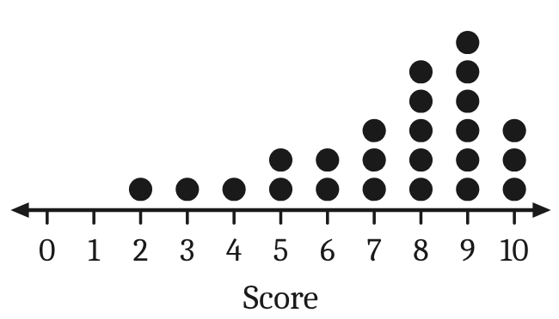
3 |  |  | 1
  The histogram shows the number of people in each of 24 cars that arrived at a beach car park. What is the mode? | 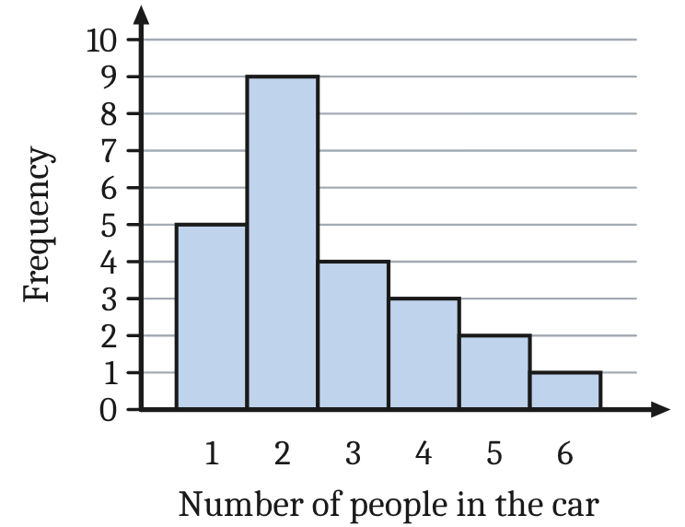
    A. 2 | B. 3.5 | C. 6 | D. 9
4 | A water polo team scored these numbers of goals in 10 games:  5, 7, 6, 8, 6, 21, 7, 5, 6, 8  Which measure of centre changes the most if the outlier, 21, is removed? |  | 1
  A. The mode | B. The median
  C. The mean | D. All three change by the same amount

 | Section 1: Data (continued)
 | Short Answer:
 | Question | Working Out | Mark
5 | The stem-and-leaf plot shows the number of minutes that 11 students spent on homework last night.  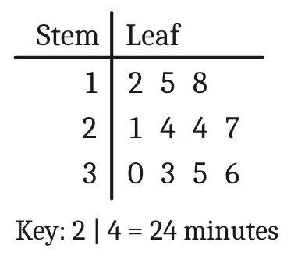  a. Find the mean.  b. Find the median.  Note: Mean = sum of the scores ÷ number of scores | a.  Sum = 12 + 15 + 18 + 21 + 24 + 24 + 27 + 30 + 33 + 35 + 36 = 275  Mean = 275 ÷ 11  25 minutes  b.  11 scores: the median is the 6th score  24 minutes | 2  1
 | Worded Problems:
 | Question | Working Out | Mark
6 | Year 9 students each chose one sport for Friday afternoon. The column graph shows how many students chose each sport.  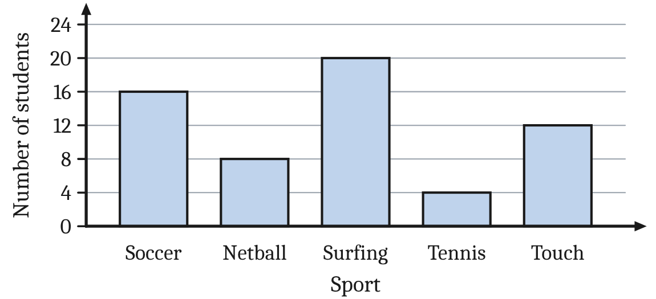
a | How many more students chose surfing than tennis? | 20 − 4  16 students | 1
b | How many students were surveyed altogether? | 16 + 8 + 20 + 4 + 12  60 students | 1
c | What percentage of the students chose surfing or tennis? | 20 + 4 = 24 students  24 ÷ 60 × 100%  40% | 2

 | Section 1: Data (continued)
 | Question | Working Out | Mark
7
  The Kestrels and the Tigers are two netball teams. The back-to-back stem-and-leaf plot shows the number of goals each team scored in its 12 games this season.  Note: Range = highest score − lowest score | 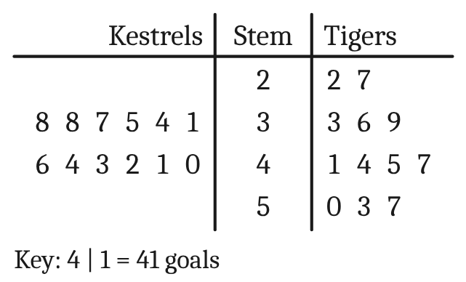
a | Find the median number of goals for each team. | Kestrels: (38 + 40) ÷ 2  Tigers: (41 + 44) ÷ 2  Kestrels: 39; Tigers: 42.5 | 2
b | Which team usually scores more goals? Give a reason. | The Tigers: their median (42.5) is higher than the Kestrels’ (39). | 1
c | Which team is more consistent? Find the range of each team to explain. | Kestrels: 46 − 31 = 15  Tigers: 57 − 22 = 35  The Kestrels: their range is 15 goals (46 − 31), much smaller than the Tigers’ 35 goals (57 − 22). | 3
 | Total |  | /17

 | Section 2: Surface area and volume
 | Multiple Choice: |  | Mark
1 | A rainwater tank holds 4.6 kL of water. How many litres is this? |  | 1
  A. 460 L | B. 46 000 L | C. 4600 L | D. 0.0046 L
2 |  |  | 1
  The scale on this measuring cylinder is shown.  What is the absolute error of a reading taken with this measuring cylinder?  Note: absolute error = ½ × precision (the smallest marked unit on the scale) | 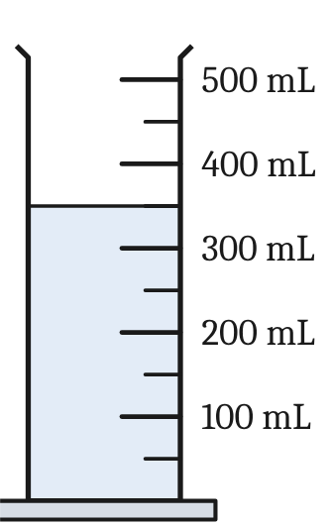
    A. ±25 mL | B. ±50 mL | C. ±100 mL | D. ±0.5 mL
3 |  |  | 1
  What is the area of this parallelogram?  Note: Area of a parallelogram: A = bh | 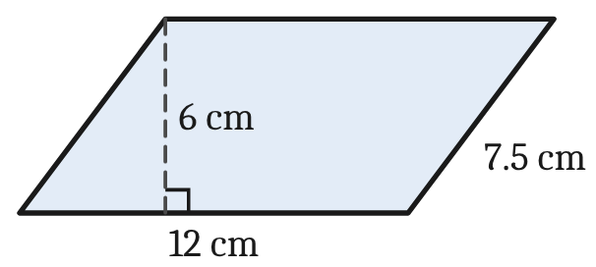
    A. 90 cm² | B. 36 cm² | C. 39 cm² | D. 72 cm²
4 |  |  | 1
  What is the area of this kite?  Note: Area of a kite: A = ½xy (x and y are the diagonals) | 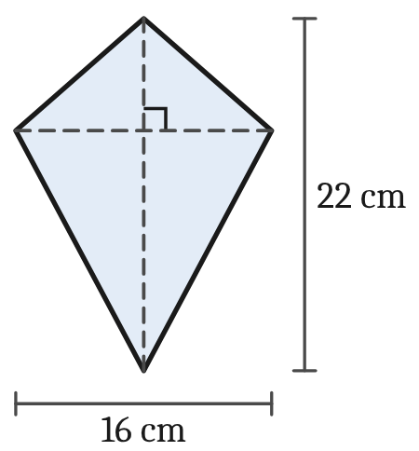
    A. 352 cm² | B. 176 cm² | C. 88 cm² | D. 38 cm²

 | Section 2: Surface area and volume (continued)
 | Short Answer:
 | Question | Working Out | Mark
5 | For this right-angled triangle, find:  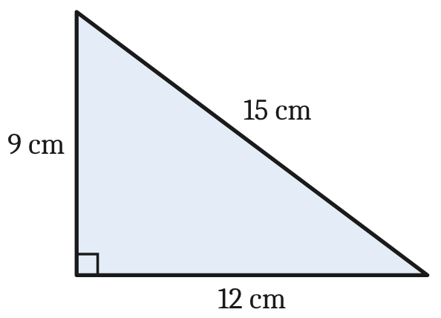  a. its perimeter  b. its area.  Note: Area of a triangle: A = ½bh | a.  P = 12 + 9 + 15  36 cm  b.  A = ½ × 12 × 9  54 cm² | 1  1
6 | For this circle, find, correct to 1 decimal place:  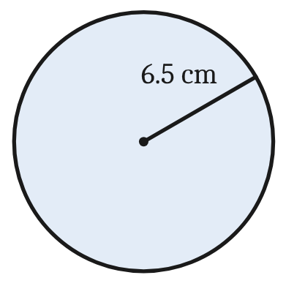  a. its circumference  b. its area.  Note: Circumference: C = 2πr  Note: Area: A = πr² | a.  C = 2 × π × 6.5 = 40.841…  40.8 cm  b.  A = π × 6.5² = 132.732…  132.7 cm² | 1  1
7 | This closed cylinder has a radius of 6 cm and a height of 15 cm.  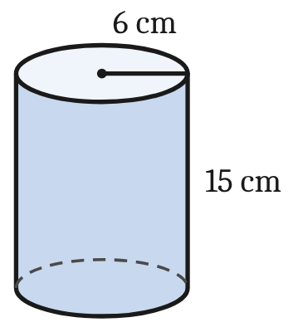  a. Find its volume, correct to 1 decimal place.  b. Find its surface area, correct to 1 decimal place.  Note: Volume: V = πr²h  Note: Surface area: SA = 2πr² + 2πrh | a.  V = π × 6² × 15 = 1696.460…  1696.5 cm³  b.  SA = 2 × π × 6² + 2 × π × 6 × 15  = 226.19… + 565.49…  791.7 cm² | 2  2

 | Section 2: Surface area and volume (continued)
 | Worded Problems:
 | Question | Working Out | Mark
8
  The plan shows an L-shaped lawn at a primary school. All of the corners are right angles.  Note: Area of a rectangle: A = lb | 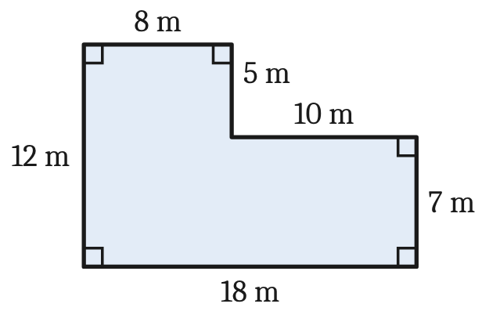
a | Garden edging is laid around the outside of the lawn. How many metres of edging are needed? | P = 18 + 7 + 10 + 5 + 8 + 12  60 m | 1
b | Find the area of the lawn. | Bottom rectangle: 18 × 7 = 126 m²  Top rectangle: 8 × 5 = 40 m²  Area = 126 + 40  166 m² | 3
c | New turf costs $12.40 per square metre. Find the cost of the turf for the whole lawn. | 166 × $12.40  $2058.40 | 1

 | Section 2: Surface area and volume (continued)
 | Question | Working Out | Mark
9
  A closed wooden storage box is a rectangular prism 60 cm long, 40 cm wide and 30 cm high. | 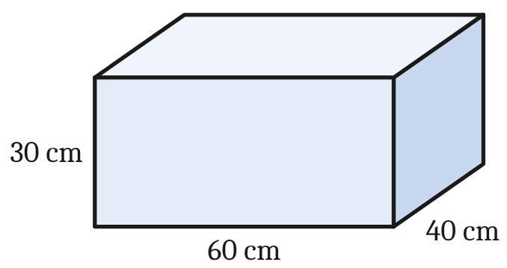
a | Find the volume of the box in cm³.  Note: Volume of a rectangular prism: V = lwh | V = 60 × 40 × 30  72 000 cm³ | 1
b | How many litres does the box hold?  Note: 1 L = 1000 cm³ | 72 000 ÷ 1000  72 L | 1
c | The outside of the box is to be painted. Find the surface area of the box.  Note: Surface area = the total area of the 6 faces; area of a rectangle: A = lb | Top and bottom: 2 × 60 × 40 = 4800 cm²  Front and back: 2 × 60 × 30 = 3600 cm²  Two ends: 2 × 40 × 30 = 2400 cm²  SA = 4800 + 3600 + 2400  10 800 cm² | 3
 | Total |  | /22

 | Section 3: Mixed Topics (Chapters 1–8)
 | Multiple Choice: |  | Mark
1 | If a = 5 and b = 3, evaluate 2a² − b. |  | 1
  A. 7 | B. 17 | C. 47 | D. 97
2 |  |  | 1
  Find the value of x. Select the closest answer.  Note: Pythagoras’ theorem: c² = a² + b² | 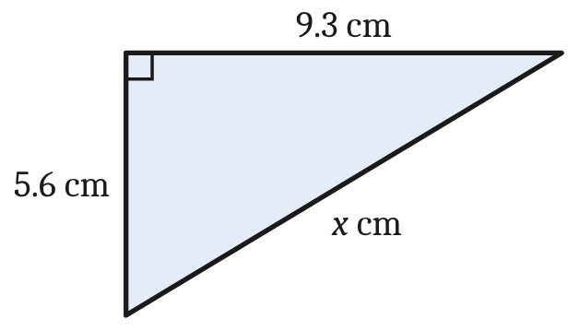
    A. 14.9 | B. 10.9 | C. 7.4 | D. 3.7
3 | A skateboard is marked at $145. In a sale it is discounted by 15%. What is the selling price? |  | 1
  A. $166.75 | B. $130.00 | C. $123.25 | D. $21.75
4 | Simplify 4m⁶ × 3m². |  | 1
  A. 12m⁸ | B. 7m⁸ | C. 12m¹² | D. 12m⁴
5 | Ella is a nurse. She earns an annual salary of $81 640. How much is she paid per fortnight?  Note: 1 year = 52 weeks = 26 fortnights = 12 months |  | 1
  A. $1570.00 | B. $3140.00 | C. $3401.67 | D. $6803.33
 | Short Answer:
 | Question | Working Out | Mark
6 | Simplify:  a. 5a + 3b − 2a + b  b. 4x × 3y  c. 18mn ÷ 6m | a.  3a + 4b  b.  12xy  c.  3n | 1  1  1

 | Section 3: Mixed Topics (Chapters 1–8) (continued)
 | Question | Working Out | Mark
7 | Expand and simplify:  3(4x − 5) − 2(x − 6) | = 12x − 15 − 2x + 12  10x − 3 | 2
8 | Factorise:  a. 6x + 15  b. y² − 8y | a.  3(2x + 5)  b.  y(y − 8) | 1  1
9 | Liam invests $7250 for 3 years at 4.2% p.a. simple interest. Calculate the interest he earns.  Note: Simple interest: I = Prn | I = $7250 × 0.042 × 3  $913.50 | 2
10 | A surf shop buys a surfboard for $480 and sells it for $612.  a. Find the profit.  b. Find the profit as a percentage of the cost price.  Note: Percentage profit = profit ÷ cost price × 100% | a.  $612 − $480  $132  b.  $132 ÷ $480 × 100%  27.5% | 1  1

 | Section 3: Mixed Topics (Chapters 1–8) (continued)
 | Question | Working Out | Mark
11 | Solve each equation.  a. 5x − 8 = 27  b. 7m − 2(m + 3) = 3m + 10 | a.  5x = 35  x = 7  b.  7m − 2m − 6 = 3m + 10  5m − 6 = 3m + 10  2m = 16  m = 8 | 2  3
12 | Jake sells cars. He is paid $520 per week plus 2.5% commission on his sales. Last week he sold $46 800 worth of cars. Calculate Jake’s total pay for the week. | Commission: 2.5% × $46 800 = $1170  Total: $520 + $1170  $1690 | 2
 | Worded Problems:
 | Question | Working Out | Mark
13 | Mia works in a bakery. Her normal rate of pay is $26.80 per hour for the first 38 hours each week. She is paid time-and-a-half for each hour after that.  Last week Mia worked 44 hours.
a | Calculate Mia’s pay for the first 38 hours. | 38 × $26.80  $1018.40 | 1
b | Calculate Mia’s total pay for the 44 hours. | Overtime: 6 × 1.5 × $26.80 = $241.20  Total: $1018.40 + $241.20  $1259.60 | 2

 | Section 3: Mixed Topics (Chapters 1–8) (continued)
 | Question | Working Out | Mark
14 | A gym charges a joining fee of $60 plus $15 per week. The total cost, C dollars, for w weeks is given by the formula  C = 60 + 15w
a | Find the total cost for 12 weeks. | C = 60 + 15 × 12  $240 | 1
b | Jo paid $300 altogether. Write an equation and solve it to find how many weeks Jo went to the gym. | 60 + 15w = 300  15w = 240  w = 240 ÷ 15  16 weeks | 2
15
  A ladder 5.2 m long leans against a vertical wall. The foot of the ladder is 1.6 m from the wall, on level ground.  Note: Pythagoras’ theorem: c² = a² + b²  Note: sin θ = $\frac{\text{opp}}{\text{hyp}}$, cos θ = $\frac{\text{adj}}{\text{hyp}}$, tan θ = $\frac{\text{opp}}{\text{adj}}$ | 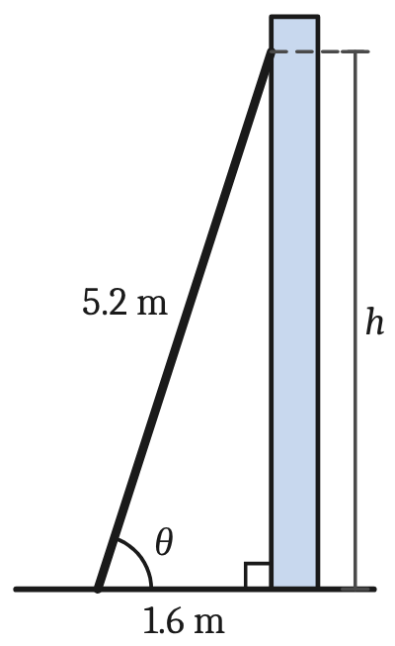
a | Find h, the height the ladder reaches up the wall, correct to 2 decimal places. | h² = 5.2² − 1.6² = 27.04 − 2.56 = 24.48  h = √24.48 = 4.9477…  4.95 m | 2
b | Find the angle θ that the ladder makes with the ground, correct to the nearest degree. | cos θ = $\frac{\text{1.6}}{\text{5.2}}$  θ = cos⁻¹(1.6 ÷ 5.2) = 72.08…°  72° | 2
 | Total |  | /33

